Manuscript template for INSTR2023 conference PAPER

Cover Page

Submission number: _______________________

Title of Manuscript

A. Corrauthor ª, B. author ^{b}, and C. Coauthor ^{c}
ª Department of Civil and Environmental Engineering,
The Hong Kong University of Science and Technology, China
Email: a.corr.author@polyu.edu.hk
^{b} Department of Civil Engineering, The University of Hong Kong, China
Email: b.author@hku.hk
^{c} ABC Corporation, U.K.
Email: c.author@abcc.uk

Keywords: Please specify up to five keywords here separated by commas.

Subject area: (Please put an “X” as appropriate, you may choose more than one)

 | 1) | Reliability and resilience of emerging mobility systems
 | 2) | COVID-19 and epidemics
 | 3) | Resilience in logistics and supply chains
 | 4) | Transportation network reliability and resilience
 | 5) | Travel behavior and user perception of reliability
 | 6) | Evacuation and disaster relief
 | 7) | Reliability of public transport
 | 8) | Public policy for reliability and resilience
 | 9) | The valuation and economics of reliability and risk
 | 10) | Network interdependencies and cyber security
 | 11) | Traffic management
 | 12) | Others (Please specify)

Preferred mode of presentation: (Please put an “X” as appropriate)
 | Zoom only |  | At the conference venue only
 | No preference

Name of presenter/key speaker:

Publishing the extended abstract on the INSTR2023 website: (Please put an “X” as appropriate)
 | Yes |  | No

Each presenting author should pay the registration fee based on the number of papers presented.

Title of Your Manuscript

A. Corrauthor ª, B. author ^{b} and C. Coauthor ^{c,}
ª Department of Civil and Environmental Engineering,
The Hong Kong University of Science and Technology, China
Email: a.corr.author@polyu.edu.hk
^{b} Department of Civil Engineering, The University of Hong Kong, China
Email: b.author@hku.hk
^{c} ABC Corporation, U.K.
Email: c.author@abcc.uk

Extended Abstract

INTRODUCTION

The full paper, in PDF format, together with the source files (Word or Latex), should be wrapped in a zip file and then submitted to the online submission system via Easy Chair by April 30, 2023.

Late submissions will not be accepted.

The manuscript should be in English.

PAPER FORMAT

Margin

Set the paper size to A4 (210 mm wide by 290 mm deep) with 25 mm margins on all sides.

Fonts

Font size is Times New Roman typeface in 11 point pitch. For the paper title, please set Bold and ALL CAPITALS.

Single Spacing

Paper Length Limit

The paper length limit is 8 pages maximum, including figures, tables, references, and appendices, but excluding the cover page. The word limit is 2500 words.

STRUCTURE OF PAPER

Cover page

The cover page of the manuscript must contain the following, and in the order specified below:

- The Paper Title
- Submission Number in the Easy Chair system
- Author Name(s) are typed in the sequence of: First name, then Middle name and Surname lastly. Surname is typed in All CAPITALS.
- Institutional Affiliation of the Author(s) (including Department, Name of Organization, and Country) and Author email address(es)
- Up to five keywords
- Subject area
- Preferred mode of presentation: Zoom Only, At the Conference Venue Only, or No Preference
- Name of Presenter or key speaker

Second and following pages

These include the main body of the paper, beginning with the title, followed by the name(s) and affiliation(s) of the author(s), then the abstract and keywords.

Positioning of Paper Title, Author Names, and Author Affiliations

- Paper title to be centered.
- Leave one blank line between the paper title and author names.
- Both author names and author affiliations to be centered.
- Leave two blank lines between author affiliations and extended abstract.

Main body of paper

The rest of the paper should be divided into sections and (optionally) subsections with sub-subsections. Sections must be numbered and their title typed in bold capitals (for example, 1. SECTIONS). Subsections must be numbered using two digits and their titles typed in bold typeface (for example, 1.1 Subsections). Sub-subsections must be numbered using three digits and their titles typed in bold typeface (for example, 1.1.1 Sub-subsections). Two blank lines must be left before each title of the sections and one blank line before each title of the subsections and sub-subsections, except for new pages.

EQUATIONS, TABLES, AND FIGURES

Equations

Equations must be typeset with the same word processor. You may also type the equation in Mathtype (which is available at www.mathtype.com, with 30 days free trial), and use its default setting. All equations must be numbered and appeared in the following format:

a + b = c | (1)

Z = Y x (U + B) | (2)

Tables

Tables are to be centred. Tables must be numbered sequentially, with their title centered above the table. Example:
Table 1. Sample of Table
Regions | A | B
Asia | 4 | 50%
Europe | 3 | 40%
Africa | 3 | 20%
America | 4 | 50%

Figures

Figures are to be centred, with the reference and caption to be centered below the figure. All Figures must be quoted in the text. Example:

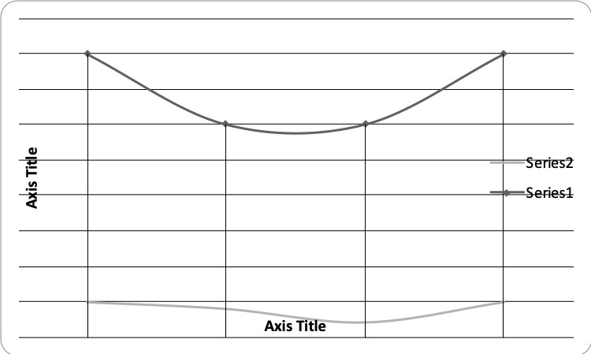
Figure 1. Sample of figure

REFERENCES

The Harvard System of referencing is recommended to be used. In the body of the text, papers or documents are referred to by the author’s surname with the year of publication in parenthesis; if the quotation is itself in parenthesis, the year of publication is separated by a comma. If the reference has more than two authors, only the surname of the first author followed by et al. in italics will appear in the body of the text.

At the end of the paper, complete references must be given alphabetically by author’s surname including: surname(s) and initials of author(s), separated by a comma, year of publication in parenthesis, title of the paper, title of the journal in italic typeface, volume of the journal, and first and last pages. In the case of books, the title of the book must be in italic typeface, with first letter capitals; the publisher and the city of publication must also be indicated. Examples:

Kanafani, A. and Abbas, M.S. (1987) Local air service and economic impact of small airports. Journal of Transportation Engineering, 113, pp. 42-55.
Button, K.J. (1982) Transport Economics. Heineman, London.
Nash, C.A. (1988) Integration of public transport: an economic assessment. Bus Deregulation and Privatisation: An International Perspective, eds J.S. Dodgson and N.P. Topham, pp. 17-46. Wiley, New York.
Grant, R.A. (1989) Building and testing a causal model and information technology’s impact. Proceedings of the Tenth International Conference on Information Systems, Boston, MA, pp. 173-184.
Cardell, N.S. (1989) Extensions of multinomial logit: the hedonic demand model, the nonindependent logit model and the ranked logit model. Ph.D. Thesis, Harvard University, U.S.A.

Corresponding author. E-mail address: author@institute.xxx.

